BUSINESS INSIGHTS REPORT: STRATEGIC IPO PERFORMANCE ANALYSIS
1. Executive Summary
This analysis involved an end-to-end evaluation of 387 IPOs to identify the core drivers of listing day success and the underlying risks associated with market entry. By correlating valuation metrics, investor demand (subscription levels), and broader market indices, we have successfully moved from raw financial data to a predictive risk-reward framework.
2. Key Visual Insights & Observations
Institutional Momentum (The QIB & NII Advantage)
Strong institutional backing (QIB > 80x) and high-net-worth participation (NII > 100x) are the most significant lead indicators for positive listing pops.
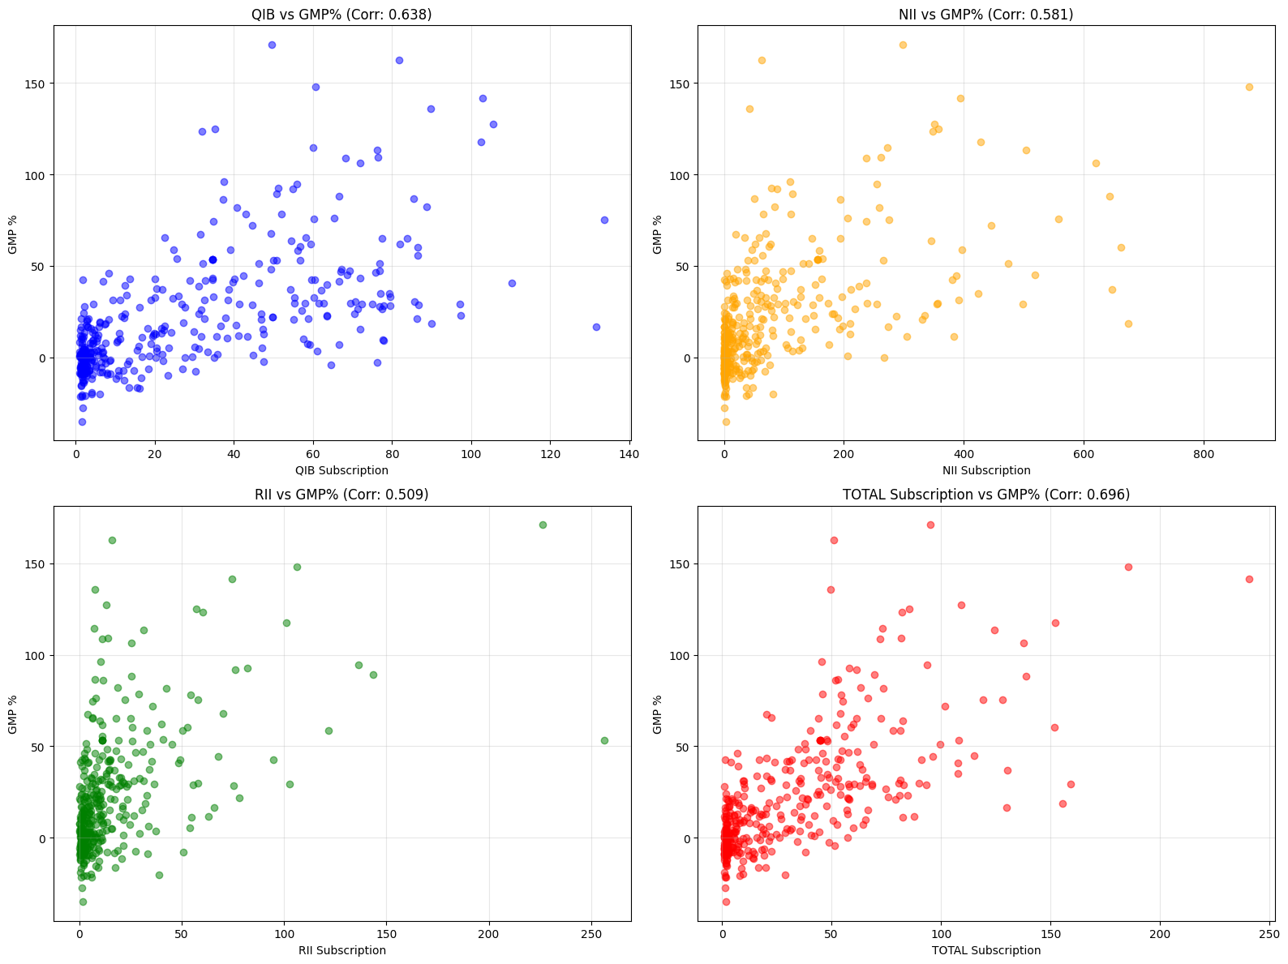
Retail Participation as a Success Floor
Retail investor sentiment (RII > 50x) serves as a robust safety net. IPOs that cross this threshold rarely experience extreme downside on the first day.
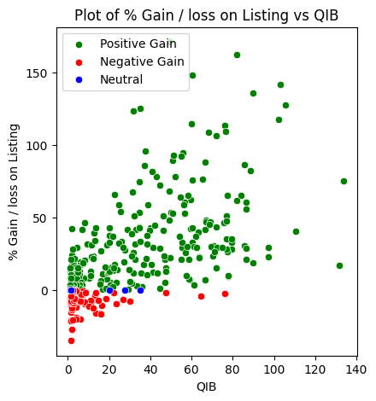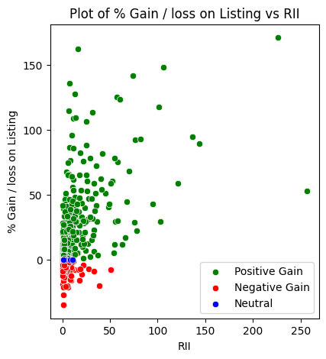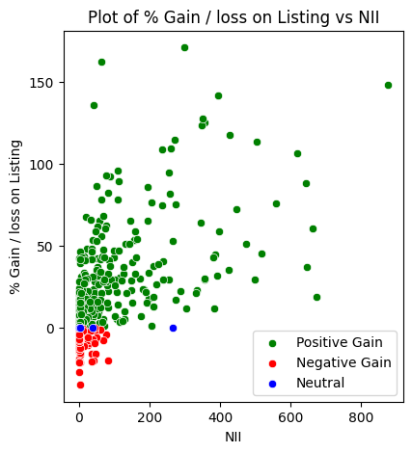
The Pricing Ceiling (The "Saturation" Threshold)
High-ticket IPOs (Upper/Lower limits near ₹2,000) are more susceptible to negative listing performance, suggesting a price point where immediate retail upside is capped.

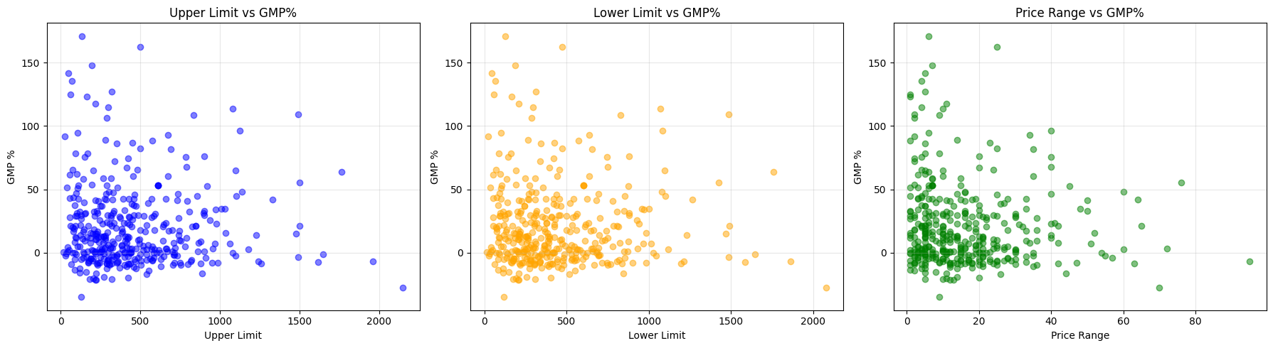
Risk in Price Volatility (Price Range Spreads)
Wide price discovery bands (Upper limit - Lower limit > ₹80) are often perceived by the market as aggressive valuation, correlating with a higher probability of negative listings.

The "Mega-IPO" Paradox (Issue Scale Risk)
Larger is not always better. IPOs with an Issue Amount > ₹15,000 CR often face liquidity hurdles on day one, leading to negative or neutral gains compared to mid-sized issues.

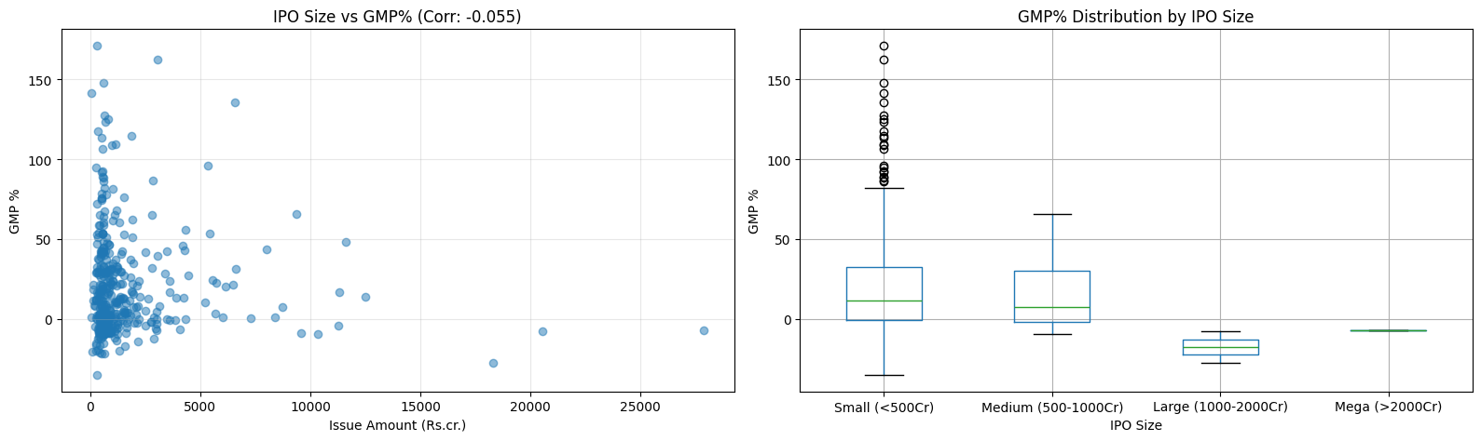
Market Capitalization Saturation
Companies entering the market with a Market Cap > ₹1 Lakh CR show a trend of negative listing performance, likely due to the massive buying volume required to drive the stock price significantly higher.
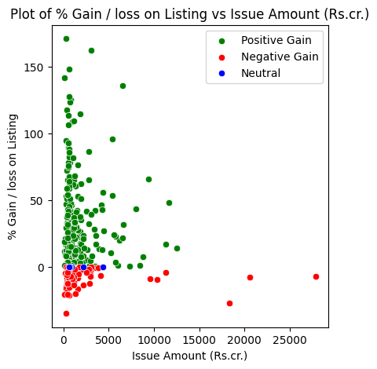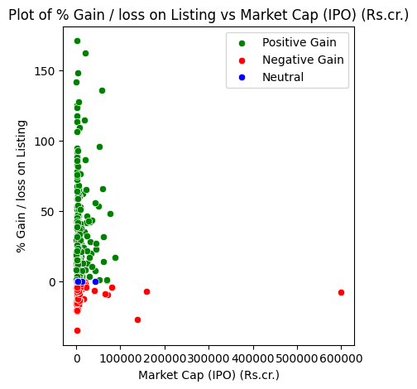

3. Strategic Business Value & Achievement
Through this analysis, we have successfully:
- Engineered Predictive Features: Identified "TOTAL Subscription" as the most critical feature for future K-Means clustering.
- Mitigated Listing Risk: Established clear valuation "Red Flags" (Price > ₹2000, Spread > ₹80) that allow investors to avoid historically poor-performing profiles.
- Benchmarked Success: Created a quantitative playbook for IPO assessment based on multi-tier subscription data.

4. Conclusion & Recommendations
- Prioritize Demand: Focus on QIB and NII velocity as the primary entry signals.
- Beware of Scale: Approach Mega-IPOs (>₹15k CR) with caution as they carry high liquidity-driven listing risks.
- Market Context: Always overlay individual IPO metrics with broader market indices (Nifty), as market sentiment remains a significant external multiplier of success.

